DIFFERENT DATA FORMATS-PARQUET,ORC,AVRO

What are Parquet, ORC, and Avro?
These are data serialization and storage formats commonly used in big data ecosystems like Hadoop, Spark, Hive, and cloud data platforms.
1. Apache Parquet
- Type: Columnar storage format.
- Features:
  - Highly efficient for analytical queries (read-heavy workloads).
  - Supports compression and encoding per column.
  - Optimized for Spark, Hive, Impala, Presto.
- Best for: Large-scale analytics where you read specific columns from huge datasets.
- Advantages:
  - Reduces I/O by reading only required columns.
  - Great for OLAP (Online Analytical Processing).

2. ORC (Optimized Row Columnar)
- Type: Columnar storage format (similar to Parquet).
- Features:
  - Developed for Hive.
  - Better compression and performance than older formats like RCFile.
  - Stores lightweight indexes for faster queries.
- Best for: Hive-based data warehouses and Hadoop ecosystems.
- Advantages:
  - High compression ratio.
  - Predicate pushdown for faster filtering.

3. Avro
- Type: Row-based storage format.
- Features:
  - Designed for data serialization (not just storage).
  - Schema evolution support (great for streaming).
  - Often used with Kafka for message serialization.
- Best for: Streaming pipelines, data interchange between systems.
- Advantages:
  - Compact binary format.
  - Easy schema evolution.

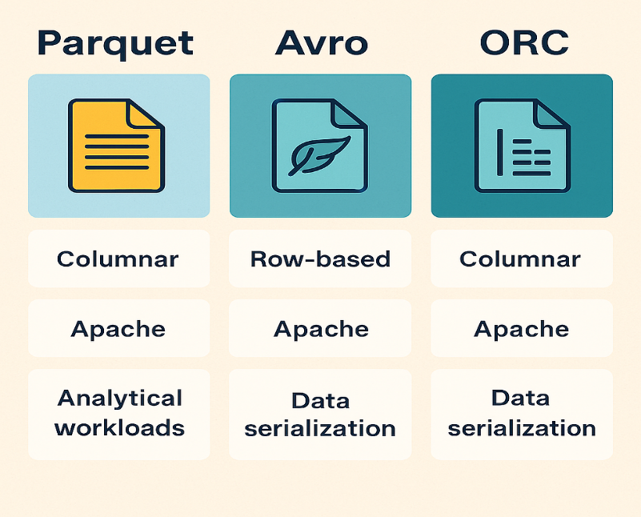

Where are they used?
- Parquet & ORC → Batch processing, data lakes, analytics (Spark, Hive, Presto).
- Avro → Streaming, messaging, ETL pipelines (Kafka, Flink).

Real-Time Use Cases
- Parquet:
  - Storing clickstream data in a data lake for BI dashboards.
  - Querying large datasets in Spark for machine learning feature extraction.
- ORC:
  - Hive tables in enterprise data warehouses.
  - ETL jobs that need high compression and fast scans.
- Avro:
  - Kafka topics for event-driven architectures.
  - Streaming IoT sensor data with schema evolution.

